* Install Artifactory server in CentOS/7

Go to /usr or any other directory:

$ wget https://bintray.com/jfrog/artifactory-pro/download_file?file_path=org%2Fartifactory%2Fpro%2Fjfrog-artifactory-pro%2F6.9.1%2Fjfrog-artifactory-pro-6.9.1.zip

$ unzip download_file?file_path=org%2Fartifactory%2Fpro%2Fjfrog-artifactory-pro%2F6.9.1%2Fjfrog-artifactory-pro-6.9.1.zip

$ mv artifactory-pro-6.9.1 artifactory

$ nohup ./artifactory.sh &

Browse the site: http://localhost:8081/artifactory/

Sign in for evaluation/free edition and use.

====================================================================

Install Artifactory and Maven plugins in Jenkins

Go to Manage Jenkins --> Configure System

Configure Artifactory plugin as given below and test connetion.

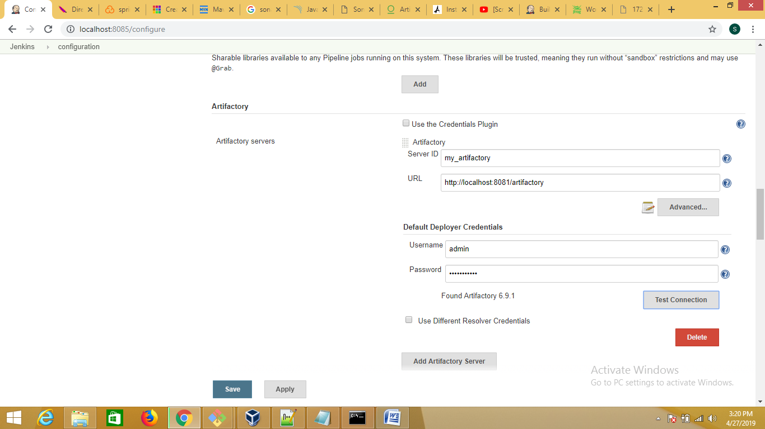

Click on the freestyle job.

Click Configure as given below:-

